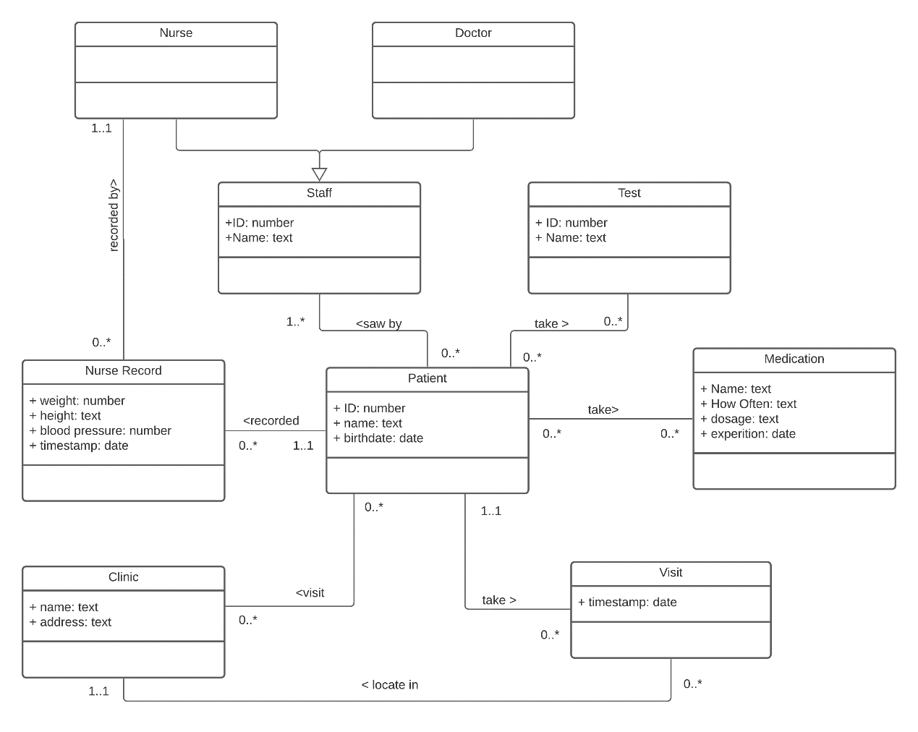

* Patient could take visit or just not take a visit. A visit must be taken by one patient.
* Patient may be prescribed one or more medicine. Patient also may have no disease, so no medicine will be prescribed to the patient. Some kind of medicine may never be used, while some medicine may be prescribed to more than one patient.
* A visit locates in only one clinic, while a clinic could never be visited or be visited several times.
* A patient may never take visits. So, patients may visit none clinic. A clinic also could never be visited by any patients.
* During every visit, the basic information of a patient is recorded by a nurse record. The patient may never take a visit. So, his information could not be record. Some patients my visit clinic several times. Their information is recorded each time. One record only records one patient’s information.
* One record is only recorded by one nurse. A nurse could record none record or several records.
* During every visit, a patient could be saw by at least one staff. One staff may have no patient. Some staff may have several patients.
* Assuming test is only test, test do not contain test results. During every visit, a patient may not have test or have one or more test. A test could be never taken or taken by several patients.
* The staff class could derivative into class nurse and class doctor. The relation between staff and these two classes is generalization.